**Picking the most likely sentence**

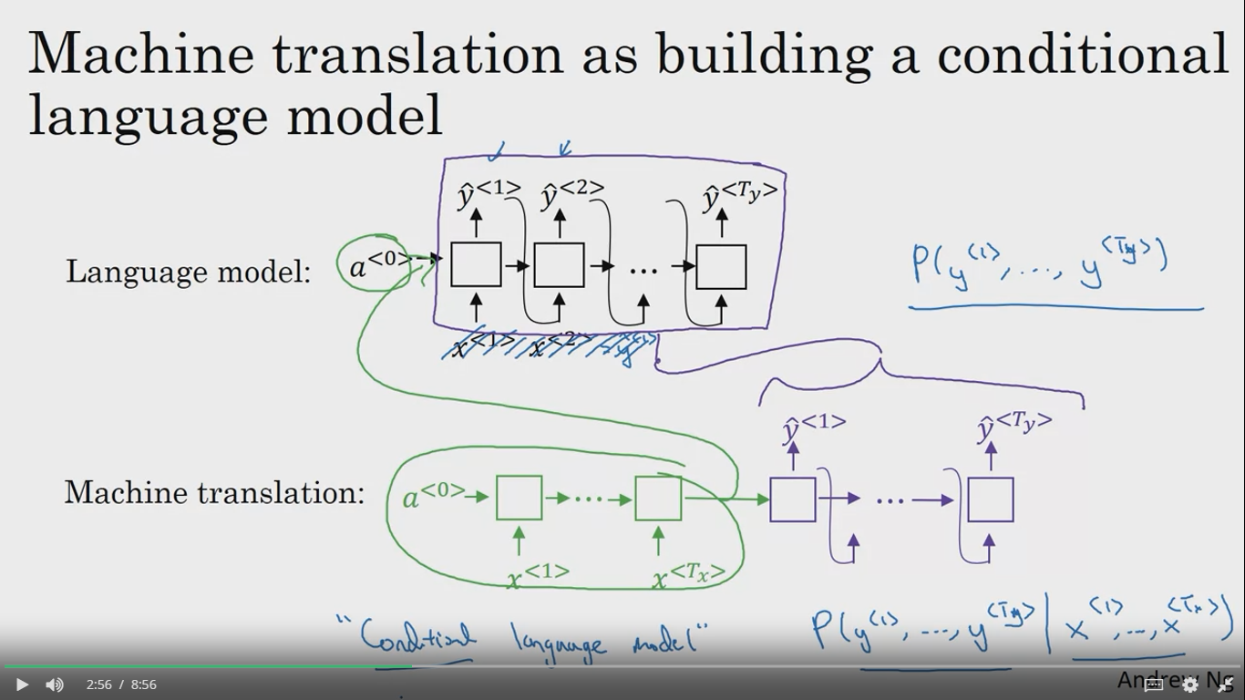

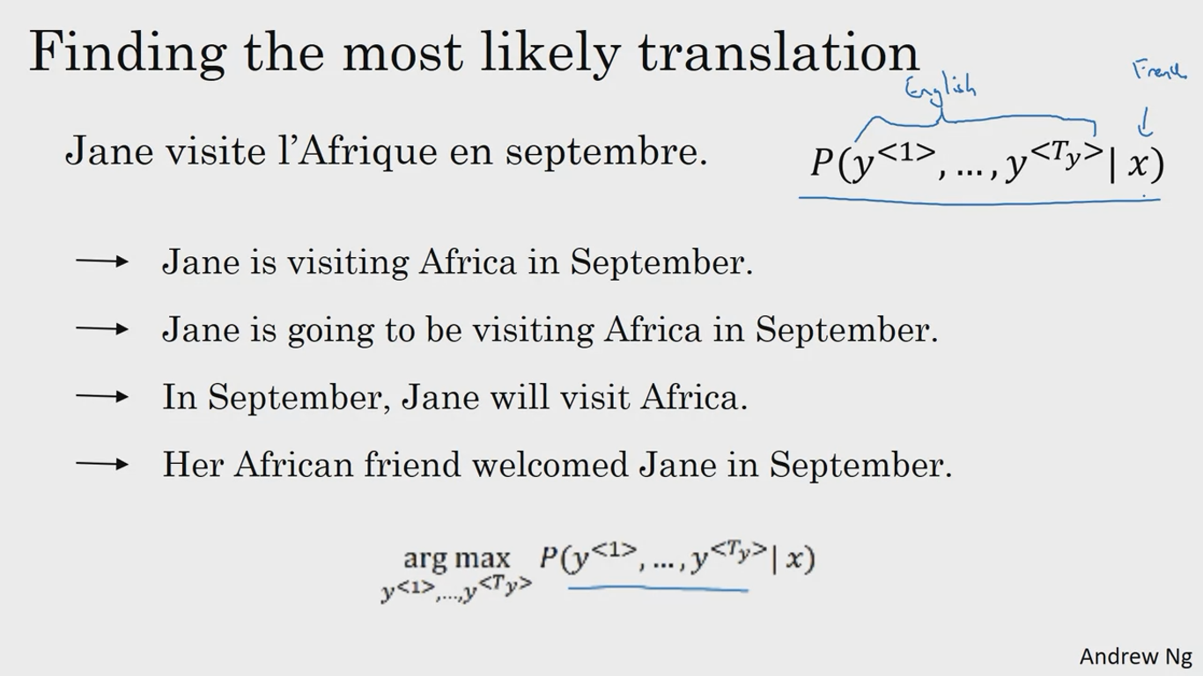

Beam search is used to maximize the last formula which is the probability of y given x

y being a sentence to be produced in English where x being a sentence in French

Greedy search will not work because if we consider starting 3 words from the below image then the probability of sentence 2 is higher than sentence 1 where sentence 1 is a good translation of the french sentence

